AutoTURN Notes
Updated October 18, 2012
To open AutoTURN go to the RD_DSN tool palette then click on the first icon on the left (or top)

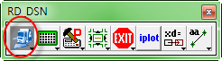

Wait for it to load. It will take about 10 seconds.

The “Welcome to AT” window will pop up

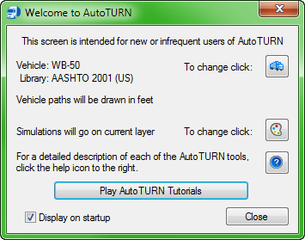

I recommend leaving the “Display on startup” box checked. At this point you have two options:

First, you can click on the [Play Auto TURN Tutorials] button and you will be walked through step-by-step instructions. This is very good for a basic set up and drawing of a vehicle path and is what I used to get started my first run through the program. However, it doesn’t go over all of the settings you may need to set/change.

Second, you can click on the [Close] button to follow the next instructions.

Click on the [Program Settings] button.

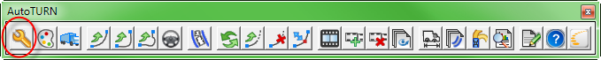

This will open up the Program Settings window. In the “Select Category” click on “General” and make sure your units are set to the units you want then click the [OK] button. Everything else should be set correctly.

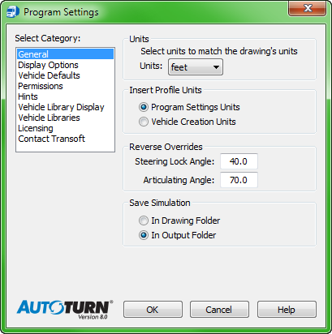

Next, click on the [Properties] button.

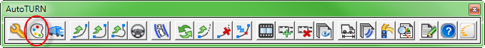

In the “Select Category” click on “General”. Here you can change the line styles and colors if you don’t like the defaults. There are eight default line styles and a “ByLayer” option. There are seven color options shown by default in the drop down menu but if you click the bottom color option “Select Color” you can pick any of our 255 colors in our color palette.

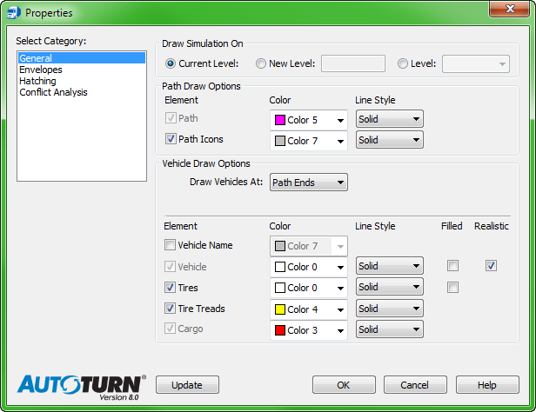

Next, in the “Select Category”, click on “Envelopes”. Again, you can change the colors and line styles if you don’t like the defaults. If you want to have the tire tracks drawn when you run your simulation you will need to check the boxes for “Front Tires” and “Rear Tires”.

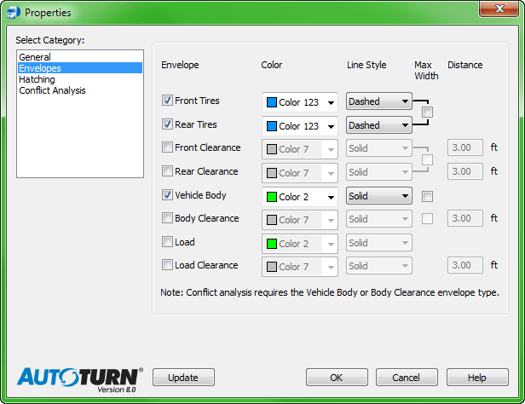

Next, click on the [Vehicles] button.

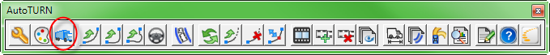

All you need to do here is choose a vehicle type for the turn you are simulating.

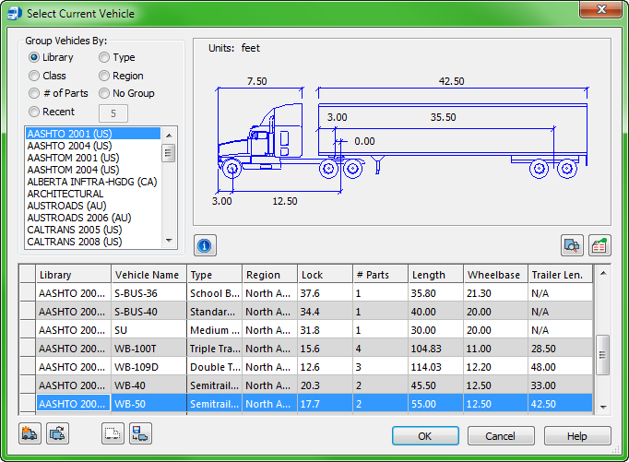

Click on the [Place Adaptive Simulation] button.

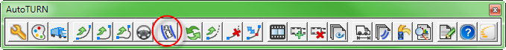

Select the elements of your path in the order the vehicle will go then accept them by clicking away from the elements.

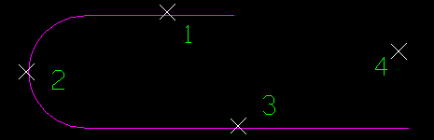
If you are re-doing the simulation on the same path a small window will come up that will ask if you want to use the previous path, otherwise just click on the new path elements.

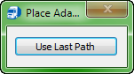

Make sure “Centered” is selected then click on [OK]

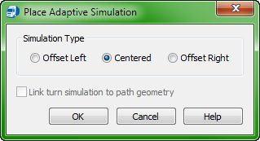

To see an animation of the track click on the [Run Animation] button.

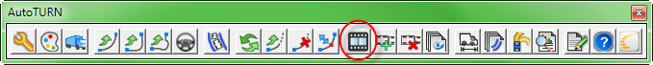

If you are running the animation before drawing it the first time, then select the elements of your path just as you would for drawing the path. If you are re-doing the simulation on the same path a small window will come up that will ask if you want to use the previous path, otherwise just click on the new path elements.

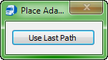

Choose an animation speed between five and eight. Five is a good slow speed for seeing how the vehicle maneuvers around obstacles. Eight is good if you have a longer path you need to get through. You can also start out fast, pause the animation and restart at a slower speed when you get closer to turn or obstacles.

